Kanban is a popular Lean workflow management method for defining, managing, and improving services that deliver knowledge work. It helps you visualize work, maximize efficiency, and improve continuously. Work is represented on Kanban boards, allowing you to optimize work delivery across multiple teams and handle even the most complex projects in a single environment.

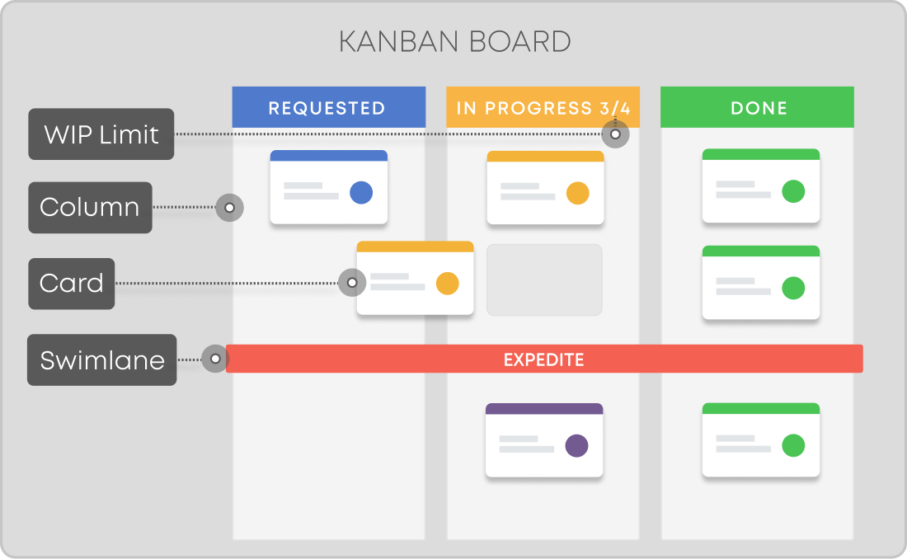

* What exactly is Kanban?
* What are the Kanban principles and practices?
* What are the benefits of adopting Kanban?
* **Kanban Definition**

The Japanese word “kanban”, meaning “visual board” or a “sign”, has been used in the sense of a process definition since the 1950s. It was first developed and applied by Toyota as a scheduling system for just-in-time manufacturing. On the other hand, the capitalized term “Kanban” is known and associated with the emergence of the “Kanban Method,” which was first defined in 2007.

## Kanban Practices

When aiming to implement the Kanban method, every organization must be careful with the practical steps. Six core practices need to be present for a successful implementation. While mastering these is vital, it’s an evolving process - [close to 40% of all organizations admit that the way they use the Kanban practices still matures](https://kanbanize.com/blog/state-of-kanban-report/). Let’s take a closer look and understand what the six practices of Kanban are.

* Visualize the workflow
* Limit work in progress
* Manage flow
* Make process policies explicit
* Implement feedback loops
* Improve collaboratively

### 1. Visualize the Workflow

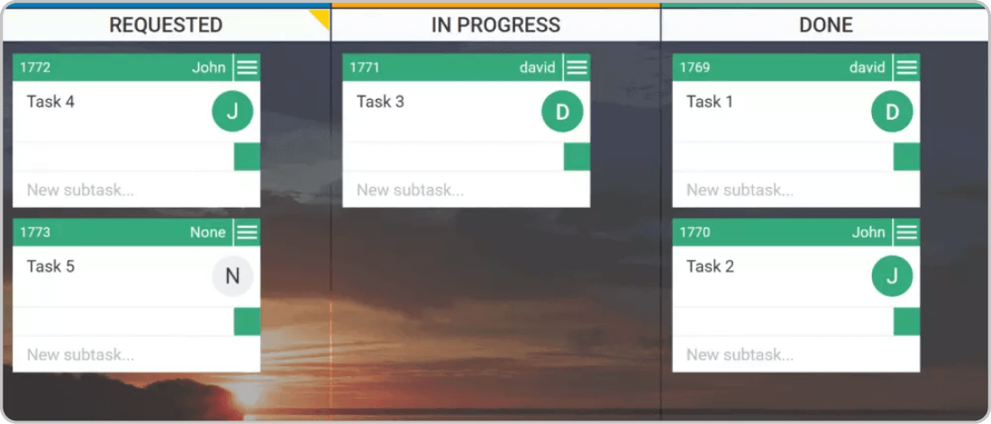A simple Kanban Board

To visualize your process with a Kanban system, you will need a board with cards and columns. Each column on the board represents a step in your workflow. Each [Kanban card](https://kanbanize.com/kanban-resources/getting-started/what-is-kanban-card/) represents a work item. The Kanban board itself represents the actual state of your workflow with all its risks and specifications.

The first and most important thing for you is understanding what it takes to get an item from a request to a deliverable product. Recognizing how work flows through your system will set you on the path to continuous improvement by making well-observed and necessary changes.

When you start working on item X, you pull it from the “To Do” column, and when it is completed, you move it to “Done”. This way, you can easily track progress and spot bottlenecks. Naturally, your Kanban board might have a different outlook depending on your specific needs and processes.

### 2. Limit Work in Progress (WIP)

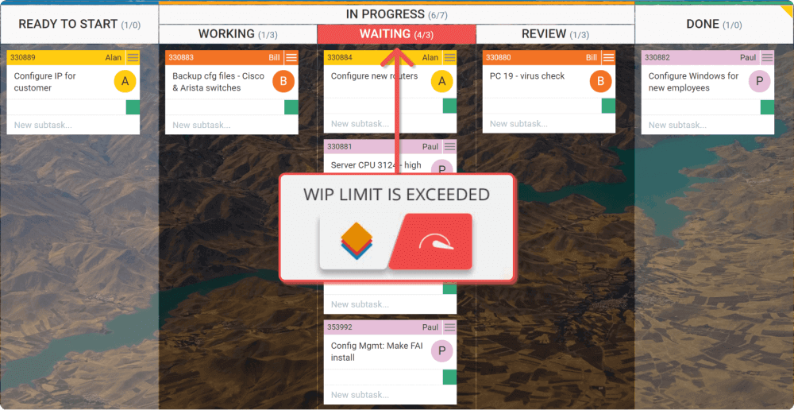  
Digital Kanban Board with WIP Limits

One of Kanban's primary functions is to ensure a manageable number of active items are in progress at any one time. If there are no [work-in-progress limits](https://kanbanize.com/kanban-resources/getting-started/what-is-wip/), you are not doing Kanban. Switching a team’s focus halfway through will generally harm the process, and multitasking is a sure route to generating waste and inefficiency.

Limiting WIP means implementing a pull system on parts or the complete workflow. Setting maximum items per stage ensures that a card is only “pulled” into the next step when there is available capacity. Such constraints will quickly illuminate problem areas in your flow so you can identify and resolve them.

### 3. Manage Flow

Managing the flow is about managing the work but not the people. By flow, we mean the movement of work items through the production process at a predictable and sustainable pace.

One of the main goals when implementing a Kanban system is to create a smooth, healthy flow. Instead of micro-managing people and trying to keep them busy all the time, you should focus on managing the work processes and understanding how to get that work faster through the system. This would mean that your Kanban system is creating value more quickly.

### 4. Make Process Policies Explicit

You can’t improve something you don’t understand. This is why your process should be clearly defined, published, and socialized.  People would not associate and participate in something they do not believe would be useful.

When everyone is familiar with the common goal, they would be able to work and make decisions regarding a positive impact. Sparse, visible, well-defined, and subject to change (if/when needed), work policies have the power to boost people’s self-organization.

### 5. Feedback Loops

For teams and companies that want to be more agile, implementing feedback loops is a mandatory step. They ensure that organizations adequately respond to potential changes and enable knowledge transfer between stakeholders.

Kanban suggests the use of cadences (feedback loops) at a team level as well as service-oriented cadences.

An example of a **team-level cadence** is the daily Team Kanban Meeting for tracking the status and the flow of work. It helps to identify available capacity and potential for increasing the delivery pace. It takes place in front of the Kanban board, and every member tells the others what they did the previous day and what they will be doing today.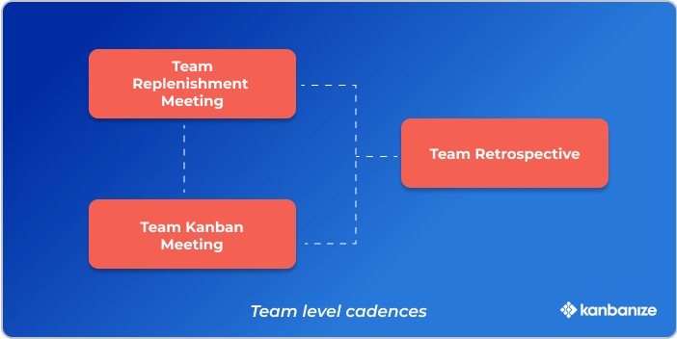

Team-level cadences

**Service-oriented cadences** in Kanban, such as operations, service delivery, and risk meetings, aim to synchronize and improve your delivery of service. The output of these reviews, such as understanding what is blocking effective service delivery, should serve as a decision-making input for the continuous improvement of your network of services.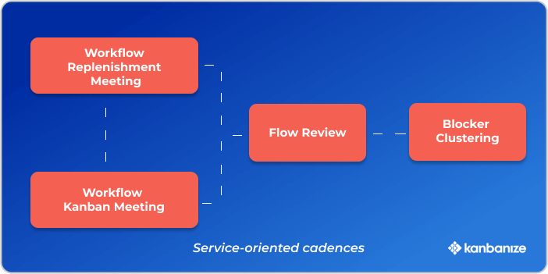

Service-oriented cadences

While focused and regular meetings with fewer attendees have proven to be a good practice, the ideal duration of specific Kanban cadences depends on your context, the team size, and topics.

### 6. Improve Collaboratively (Using Models & the Scientific Method)

The way to achieve continuous improvement and sustainable change within an organization is through collaboratively implementing changes based on scientifically proven methods, feedback, and metrics.

Cultivating an organizational culture where every hypothesis is proven to have positive or negative results is crucial for developing a mindset focused on improvement through evolutionary change.

## Top 6 Benefits of Kanban

According to the 1st State of Kanban report, the leading reasons for adopting the Kanban method are the need for **enhanced visibility of work** and **continuous improvement**. Let’s reveal some more of the benefits of using Kanban today.

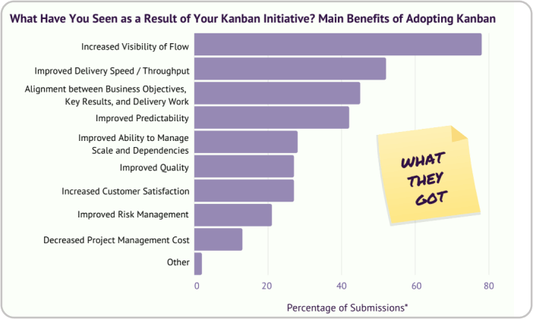

* Increased visibility of the flow
* Improved delivery speed
* Alignment between goals and execution
* Improved predictability
* Improved dependencies management
* Increased customer satisfaction

### Increased Visibility of the Flow

The basic idea of Kanban is visualizing every piece of work. This way, the Kanban board turns into a central informational hub, and everyone is on the same page. All tasks are visible, and they never get lost, which brings transparency to the whole work process. Every team member can have a quick update on the status of every project or task.

### Improved Delivery Speed

Kanban offers multiple ways for project managers to closely monitor and make informed analyses of the distribution of work. With a clear view over the work items completed for a certain period of time, the stages where tasks spend the longest, and bottlenecks are easy to identify. Teams are enabled to tackle these challenges to improve their workflow and, ultimately, their delivery rate.

### Alignment between Business Goals and Execution

Promoting transparency, encouraging feedback, and regular review meetings, Kanban practices enable aligning the company’s strategic goals with teams' day-to-day work. This [alignment between the business direction and execution enhances the agility of an organization](https://kanbanize.com/agile/scaled-agile/okrs-in-agile). It allows teams to adapt to changing priorities and reorganizations due to changes in the market or customers’ requirements.

### Improved Predictability

Once you create a Kanban board and start accumulating work items on it, you’ll be able to understand your process in depth with flow metrics. Analyzing the time tasks spend in your workflow (cycle time) will enable you to improve your predictions on how much work you can deliver in the future. Understanding your delivery rate consistency (throughput) will make your forecasts more accurate and your decisions based on historical data.

### Improved Ability to Manage Scale and Dependencies

The intrinsic Kanban practice of visualization is also applied when it comes to mapping and managing dependencies. Starting with what you do now means visualizing the present dependencies and managing the flow between them. Managing dependencies provides both insights into the present state of a workflow and ideas for improvement. On the other hand, it also enables full transparency for strategic management over the workflow and the existing links between teams.

### Increased Customer Satisfaction

The origin of the Kanban method - the [pull system](https://kanbanize.com/lean-management/pull/what-is-pull-system) it is based on implies that work is done when there’s a demand. In other words, Kanban navigates you to reduce waste by working solely on tasks that are needed at present. Furthermore, by applying visualization techniques and introducing work-in-progress limits to the process, you will ensure that the end result is fine-tuned to your customer’s expectations.

## Scrum vs. Kanban

The most important difference between Kanban and Scrum is that the former is a method, while the latter is a framework. Kanban builds a continuous delivery model where teams release value as soon as they are ready, while Scrum organizes work in Sprints. Applying either one depends on the nature of your process, however, it can be said that Kanban offers a more tailor-made approach while Scrum relies on predetermined rules. Another key distinguishing characteristic between the two is the mindset and founding belief systems of [Scrum and Kanban](https://kanbanize.com/kanban-resources/kanban-software/kanban-vs-scrum-software).

|  |  |  |
| --- | --- | --- |
|  | **Kanban** | **Scrum** |
| Nature | Kanban is an adaptive method | Scrum is a prescriptive framework |
| Principles | 1. Start with what you do now  2. Agree to pursue evolutionary change  3. Encourage acts of leadership at all levels  4. Focus on customer’s needs  5. Manage the work  6. Regularly review the network of services | 1. Empiricism  2. Transparency  3. Inspection  4. Adaptation |
| Cadences | - Team-level cadences  - Service-oriented cadences | - Sprint with a fixed length  - Sprint planning  - Daily Scrum  - Sprint Review  - Sprint Retrospective |
| Roles | - Service Delivery Manager*  - Service Request Manager*  (*no pre-defined roles are required) | - Product Owner  - Scrum Master  - Development Team |
| Metrics | - Cycle Time  - Throughput  - Work In Progress | - Velocity  - Planned Capacity |

## Applying Kanban Across the Organization for Enterprise Agility

By nature, Kanban is an adaptive method that is applicable at all organizational layers. You can use connected Kanban boards to map the management of your portfolios and connect strategy to execution. With the help of the [Portfolio Kanban](https://kanbanize.com/kanban-resources/portfolio-kanban/what-is-portfolio-kanban) concept, organizations can reap the benefits of Kanban's principles and practices across multiple management levels.   
   
The Portfolio Kanban approach can be used in four different forms:

* Team-level Portfolio Kanban
* Portfolio Kanban on the Project/Product level
* Portfolio Kanban on the Program level
* Portfolio Kanban on the Strategic level

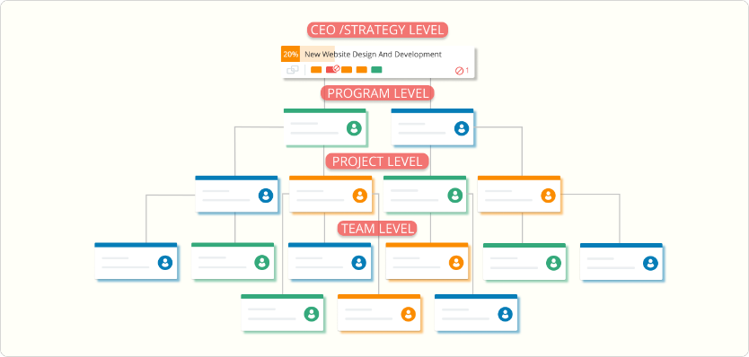Portfolio Kanban Scheme

## What Are the Main Kanban Terms You Should Know?

At its core, Kanban is a work method that helps you optimize the flow of value through your value streams from ideation to customer. Although it looks like an easy way to improve your work processes, Kanban is more than visualizing your work. You need to pay attention to detail and get familiar with the basic Kanban terms and artifacts if you want to benefit from applying the method.

Here is a short [Kanban glossary](https://kanbanize.com/kanban-resources/getting-started/kanban-encyclopedia) that will help you get started.

* **Kanban board:**  A Kanban board is one of the Kanban method's key components and is where you visualize all work items. It should be divided into a minimum of 3 columns – Requested, In Progress, Done, representing different process stages.
* **Kanban card:** Kanban cards represent the different work items moving through a Kanban board. They contain important details about the tasks, such as description, deadline, size, assignees, etc.
* **Columns:** They split the Kanban board vertically, and each of them represents a different stage of the workflow. Each Kanban board has 3 default columns: Requested, In Progress, Done. Depending on the complexity of a work process, these three stages can be divided into many smaller sub-columns.
* **Swimlanes:** Horizontal lanes that split a Kanban board into sections. Teams use them to visually separate different work types on the same board and organize homogenous tasks together.
* **Cycle Time:** Cycle time begins at the moment when a new task enters the “in progress” stage of your workflow, and somebody is actually working on it.
* **Lead Time:** Lead time starts at the moment a new task is being requested (it doesn’t matter if somebody is actually working on it) and ends with its final departure from the system.
* **Throughput:** The number of work items passing through (completed) a system or process over a certain period. The throughput is a key indicator showing how productive your team is over time.
* **Work in Progress (WIP):** This is the amount of work you are currently working on, and it is not finished yet.
* **WIP limits:** Limiting work in progress means limiting the number of tasks your team can work on simultaneously to avoid overburdening and context-switching.
* **Classes of Service:** Set of policies that help Agile teams prioritize work items and projects.
* **Kanban Cadences:** Cyclical meetings that drive evolutionary change and “fit for purpose” service delivery.
* **Kanban software:** Refers to a digital system that allows the practical application of the Kanban practices and principles to be used by various teams and organizations of all sizes.